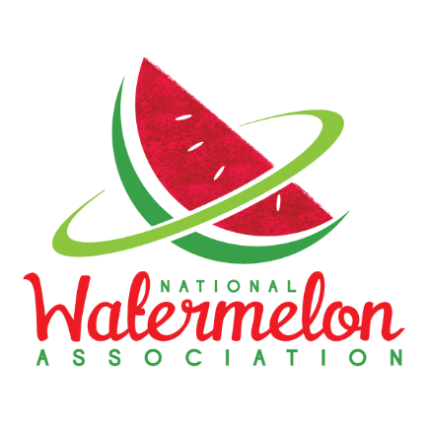

107th National Watermelon Association

Convention & Annual Meeting

February 20-27, 2022

Sheraton Grand Downtown Nashville

623 Union Street

Nashville, TN 37219

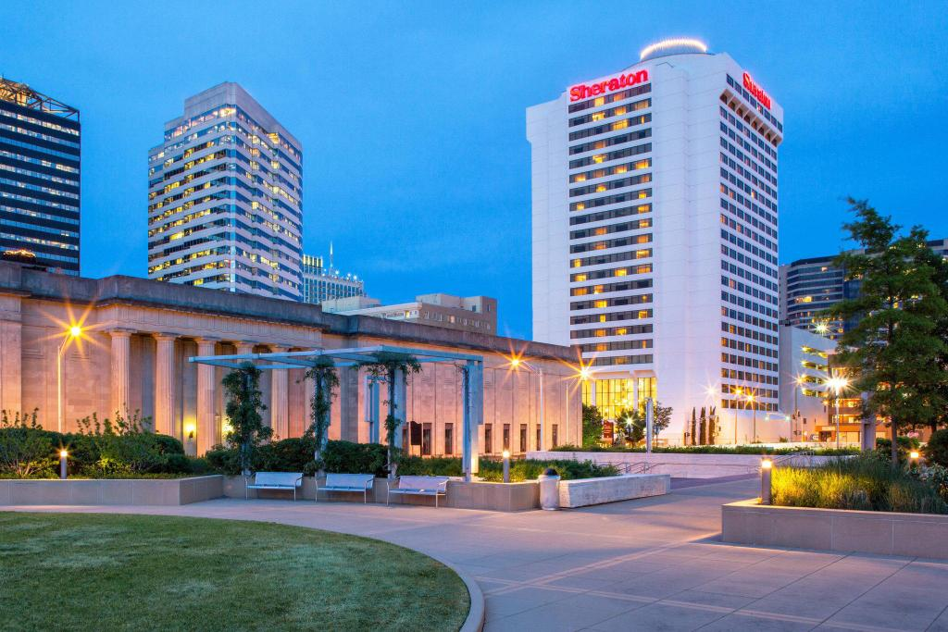

Room Rate: Standard Room: $239/night

+15.25% tax and $2.50 city tax per night

Reservations Deadline = Tuesday, February 1, 2022 (5:00 PM CST)

](https://www.marriott.com/hotels/travel/bnand-sheraton-grand-nashville-downtown/)

Here's your reservation link guests can use to make reservations:

|  |
| --- |
| [**Book your group rate for NATIONAL WATERMELON ASSOCIATION**](https://urldefense.com/v3/__https:/www.marriott.com/events/start.mi?id=1635448741098&key=GRP__;!!FOfmI8qiWcWBHqypJtzENF0!nnbAews69YEVnKd3rr-_OY9SnrxYm-IwgZjIRh3tgmUDXglvjjftbAdrHwtbfB_jWDwRNw$)  You will find the information for your online reservation in the link provided. If you have any questions or need help with the link, please do not hesitate to ask. |
|  |
| **NATIONAL WATERMELON ASSOCIATION** |
| **Start Date: Sunday, February 20, 2022** |
| **End Date: Sunday, February 27, 2022** |
| **Last Day to Book: February 1, 2022** |
| **The hotel is offering your special group rate:** |

**Sheraton Grand Nashville Downtown for $239 per night**

[**Book your group rate for NATIONAL WATERMELON ASSOCIATION**](https://urldefense.com/v3/__https:/www.marriott.com/events/start.mi?id=1635448741098&key=GRP__;!!FOfmI8qiWcWBHqypJtzENF0!nnbAews69YEVnKd3rr-_OY9SnrxYm-IwgZjIRh3tgmUDXglvjjftbAdrHwtbfB_jWDwRNw$)

[**https://www.marriott.com/event-reservations/reservation- link.mi?id=1635448741098&key=GRP&app=resvlink**](https://www.marriott.com/event-reservations/reservation-%09link.mi?id=1635448741098&key=GRP&app=resvlink)

**- - - - - - - - - -**

**Or, you can choose to call:**

**(615) 259-2000**

**Keywords: ‘National Watermelon Association’**