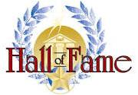

Sponsored by:

The National Watermelon Association Hall of Fame, with its beginnings in 2014, honors the distinguished leaders who have made significant, long-lasting contributions to the Association. Their individual contributions have helped to advance and ensure that the Association continues to thrive for many years. Their unselfish efforts to nurture and promote our country’s oldest fruit commodity association is deserving of our highest honor.

A selection committee representing various facets of the National Watermelon Association will review the nominations and select the recipient(s) for each honor and induction.

A permanent display of the honorees is displayed in the offices of the National Watermelon Association as a tribute to those leaders that have risen to the highest recognition of all, the National Watermelon Association Hall of Fame. In addition, a Hall of Fame page is maintained on the NWA website to pay tribute to the inductees.

All nomination forms and supporting information will be due to the Selection Committee by December 1st to be considered for the next induction. Any information received after this date will be considered in the following year.

When a nomination is submitted, please provide as much detail and relevant information to support the nominee's contributions as you can. If possible, include a photo of the nominee (if one is available). The nominee’s impact on the Association in particular will be the primary and main consideration; the nominee’s impact on the watermelon industry will be a secondary consideration; and finally, other activities that may be of interest will be considered.

All nominations must be submitted using the Nomination form. Electronic nominations via email (Microsoft WORD or PDF files) are encouraged.

Please provide information that is creative, but not too lengthy. The form, related documents and any support materials should be emailed (or mailed) to the attention of the Selection Committee. We hope that you will join us in our quest to make these select leaders and their accomplishments known to future generations for many years to come.

NATIONAL WATERMELON ASSOCIATION
Hall of Fame

NOMINATION INSTRUCTIONS

DEADLINE: All nominations (with supporting documentation) must be postmarked (or emailed) to the National Watermelon Association no later than December 15th.

Please read this document carefully and be as specific and as concise as you can.

If some of the requested information is no longer available, please make note of it on the application.

Applications are preferred in either Microsoft WORD or PDF files.

A. Personal information
1. Full name of nominee
a. Please indicate if living or deceased
2. Preferred name (or nickname if used)
3. Spouse’s name
a. Please indicate if living or deceased
4. Mailing address of nominee (if living)
a. If deceased, please indicate the date of death
B. General background information
1. Date of birth (if available)
2. Education
3. Employment
4. Organizational memberships (and any offices held) including Boards/Associations/Commissions
5. Honors, awards, citations and other recognition of a meritorious nature

C. Please include the following:
1. State why you think the nominee should be recognized in the Hall of Fame
(not to exceed 250 words).
2. Outline the nominee’s major contribution(s) to the Association
(not to exceed 250 words).
3. Highlight any additional information that does not properly fit into other sections of this nomination (not to exceed 250 words).

D. Also to be included:
1. At least one (1) photograph suitable for publication (if available)

E. Nominator information:
1. Include your name, mailing address (including ZIP code), business affiliation, telephone number and email address.
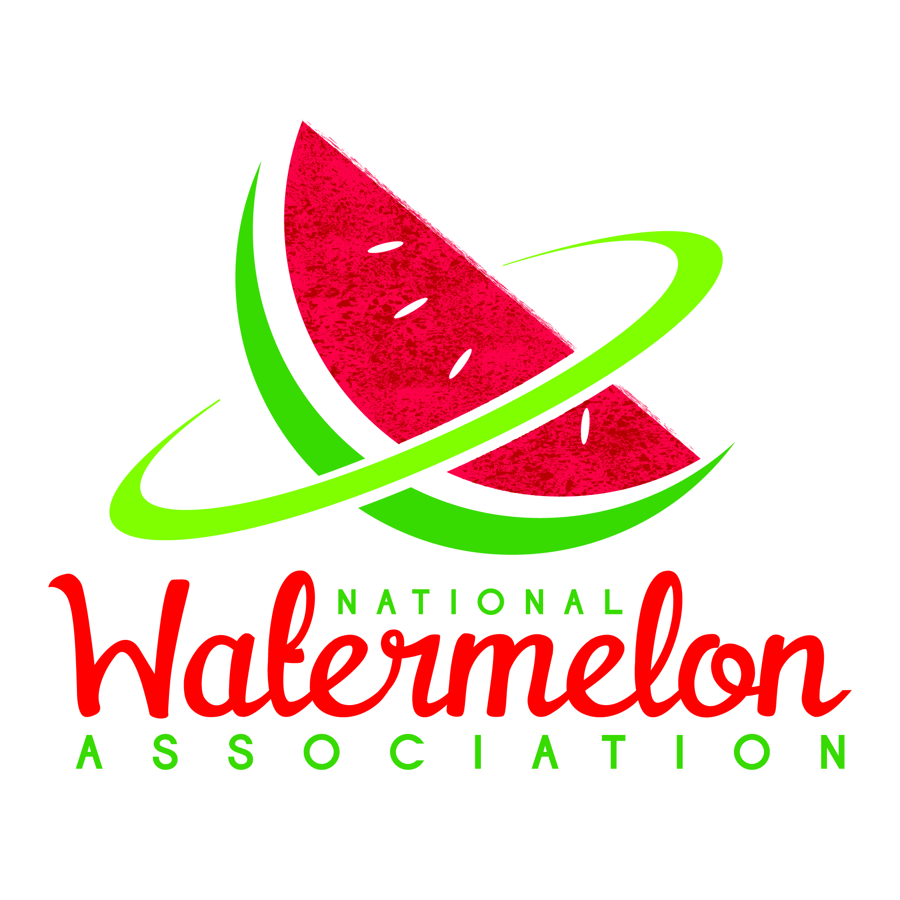
Hall of Fame

DEADLINE: Postmarked/Emailed by December 15, 2021

Name of Nominee _____________________________________________________________________

Living ________ Date of Birth of Nominee _______________________________

Deceased ________ Date of Death of Nominee ______________________________

Name of Spouse (if married) ____________________________________________________________

Living ________ Deceased ________

Primary Occupation of Nominee __________________________________________________________

____________________________________________________________________________________

Nominee’s Contact Information: (if deceased, list the closest living relative)
(Mailing address, city/state/zip code and/or email address)

____________________________________________________________________________________

____________________________________________________________________________________

Nominee’s Education: __________________________________________________________________

____________________________________________________________________________________

Nominee’s Organizational Memberships ___________________________________________________

____________________________________________________________________________________

____________________________________________________________________________________

List any offices held by nominee __________________________________________________________

____________________________________________________________________________________

Honors, Awards and other recognitions ____________________________________________________

____________________________________________________________________________________

In 250 words or less, state why you think the nominee should be recognized in the National Watermelon Association Hall of Fame. What makes the nominee deserving of our highest honor and recognition?

____________________________________________________________________________________

____________________________________________________________________________________

____________________________________________________________________________________

____________________________________________________________________________________

____________________________________________________________________________________

____________________________________________________________________________________

____________________________________________________________________________________

____________________________________________________________________________________

____________________________________________________________________________________

____________________________________________________________________________________

In 250 words or less, outline what the nominee did for the Association that should be recognized (and remembered) for generations to come?

____________________________________________________________________________________

____________________________________________________________________________________

____________________________________________________________________________________

____________________________________________________________________________________

____________________________________________________________________________________

____________________________________________________________________________________

____________________________________________________________________________________

____________________________________________________________________________________

____________________________________________________________________________________

____________________________________________________________________________________

In 250 words or less, highlight any additional information that supports their recognition in the Hall of Fame? Contributions to the watermelon industry? Civic duties/service? Other?

____________________________________________________________________________________

____________________________________________________________________________________

____________________________________________________________________________________

____________________________________________________________________________________

____________________________________________________________________________________

____________________________________________________________________________________

____________________________________________________________________________________

____________________________________________________________________________________

____________________________________________________________________________________

____________________________________________________________________________________

The selection committee will also accept and review up to three (3) letters of recommendation. Letters of recommendation can be written by family, friends, colleagues and any other people that will help you to support your nomination.

If you choose to submit any letters of recommendation with the nomination, please limit each letter to one page, and include the letter(s) in the nomination packet.

The requirements of the nominations include:

The completed nomination form
Picture(s) of the nominee (if available)
Letter(s) of recommendation (if available)

All supporting materials in the nomination should be postmarked or emailed by December 15, 2021 to:

BY MAIL:
National Watermelon Association
Hall of Fame Selection Committee
190 Fitzgerald Road
Suite 3
Lakeland, Florida 33813

BY EMAIL:
Bob Morrissey, Executive Director
bobm@nwawatermelon.com

Nominated by: _______________________________________________________________________

Your Address ________________________________________________________________________

________________________________________________________________________

Your Business Name _________________________________________________________________

Your Office Phone __________________________ Your Cell Phone __________________________

Your Email Address _________________________________________________________________

